Assignment on Time Series Analysis & Forecasting

Course Instructor: Md. Siddikur Rahman, PhD

1. Below are the net sales in $ million for Home Depot, Inc. and its subsidiaries from 2015 to 2024.

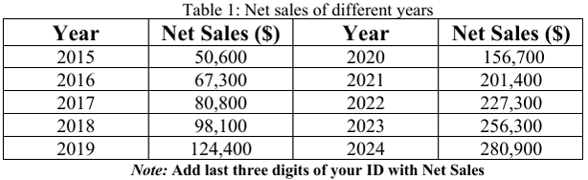

1. Determine the least square equation. Based on this information, what are the estimated sales for 2030?
2. ii) Plot Net Sales and Trend Line

Solution:

|  |  |  |  |
| --- | --- | --- | --- |
| Year(X) | Net Sales($)(Y) | XY | XX |
| 2015 | 50600030 | 1.01959E+11 | 4060225 |
| 2016 | 67300030 | 1.35677E+11 | 4064256 |
| 2017 | 80800030 | 1.62974E+11 | 4068289 |
| 2018 | 98100030 | 1.97966E+11 | 4072324 |
| 2019 | 124400030 | 2.51164E+11 | 4076361 |
| 2020 | 156700030 | 3.16534E+11 | 4080400 |
| 2021 | 201400030 | 4.07029E+11 | 4084441 |
| 2022 | 227300030 | 4.59601E+11 | 4088484 |
| 2023 | 256300030 | 5.18495E+11 | 4092529 |
| 2024 | 280900030 | 5.68542E+11 | 4096576 |
| 20195 | 1543800200 | 3.11994E+12 | 40783885 |

m = (n∑xy - ∑y∑x)/[n∑x2 - (∑x)2] Here, n=10; ∑x=20195; ∑y=1543800200

∑xy = 3.1199E+12;

∑x2 =40783885

m= (10*3.1199E+12-1543800200*20195)/[10*40783885-201952]

= 3*107

b = (∑y – m ∑x)/n

= (1543800200-3*107*20195)/10

= -5*1010

y = 3*107x- 5*1010

For x=2030 we get y = 1.09*1010 $

1. It appears that the imports of carbon black have been increasing by about 10 percent annually.

Table 2: Amount of Carbon Block imported in different years.

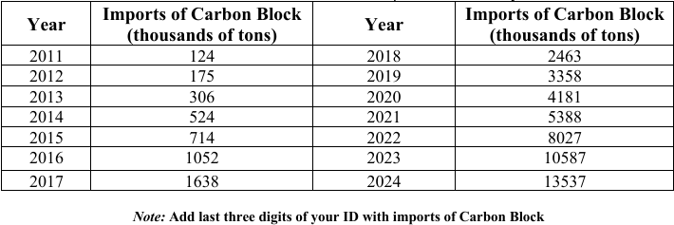

1. Determine the logarithmic trend.
2. Find the annual rate of increase.
3. Estimate imports for the year 2030.

Solution:

|  |  |  |  |
| --- | --- | --- | --- |
| Sl No | Year(X) | Imports of Carbon Block(Thousands of tons)(Y) | log(Y) |
| 1 | 2011 | 124030 | 5.093492 |
| 2 | 2012 | 175030 | 5.243088 |
| 3 | 2013 | 306030 | 5.48575 |
| 4 | 2014 | 524030 | 5.719348 |
| 5 | 2015 | 714030 | 5.85371 |
| 6 | 2016 | 1052030 | 6.022024 |
| 7 | 2017 | 1638030 | 6.214319 |
| 8 | 2018 | 2463030 | 6.391468 |
| 9 | 2019 | 3358030 | 6.526083 |
| 10 | 2020 | 4181030 | 6.621282 |
| 11 | 2021 | 5388030 | 6.731429 |
| 12 | 2022 | 8027030 | 6.904554 |
| 13 | 2023 | 10587030 | 7.024774 |
| 14 | 2024 | 13537030 | 7.131523 |

Here slope, m is the annual rate of increase. Which is m = 0.1571

The logarithmic trend equation is,

Log(y) = 0.1571x – 310.71

For x = 2030 we get Log(y) = 8.203

Thus, Imports of Carbon Block (thousands of tons) in 2030 = 159587914.7

1. The quarterly production of pine lumber, in millions of board feet, by Northwest lumber since 2018 is:

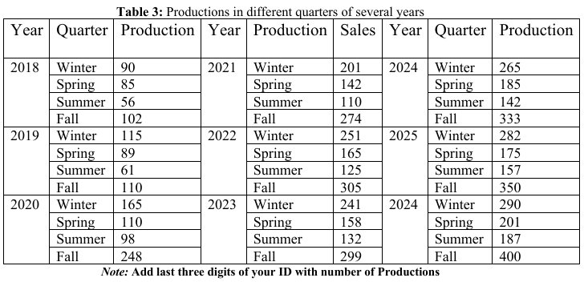

1. Develop a seasonal index for each quarter and interpret it.
2. Project the production for 2030 and also find the base year production.
3. Plot the original data, deseasonalize data, and interpret.

Solution:

|  |  |  |  |  |  |
| --- | --- | --- | --- | --- | --- |
| Year | Winter(production) | Spring(production) | Summer(production) | Fall(production) | Mean |
| 2018 | 90030 | 85030 | 56030 | 102030 | 83270 |
| 2019 | 115030 | 89030 | 61030 | 110030 | 93770 |
| 2020 | 165030 | 110030 | 98030 | 248030 | 155270 |
| 2021 | 201030 | 142030 | 110030 | 274030 | 181770 |
| 2022 | 251030 | 241030 | 165030 | 158030 | 203770 |
| 2023 | 125030 | 132030 | 305030 | 299030 | 215270 |
| 2024 | 265030 | 185030 | 142030 | 333030 | 231270 |
| 2025 | 282030 | 175030 | 157030 | 350030 | 241020 |
| 2026 | 290030 | 201030 | 187030 | 400030 | 269520 |

**Seasonal Index calculation:** Divide seasonal value of each year with the mean of each year. Then we get,

|  |  |  |  |  |
| --- | --- | --- | --- | --- |
| Year | Winter(production) | Spring(production) | Summer(production) | Fall(production) |
| 2018 | 1.0810 | 1.0210 | 0.6727 | 1.2251 |
| 2019 | 1.2266 | 0.9493 | 0.6507 | 1.1732 |
| 2020 | 1.0627 | 0.7085 | 0.6312 | 1.5973 |
| 2021 | 1.1059 | 0.7813 | 0.6052 | 1.5075 |
| 2022 | 1.1867 | 0.7801 | 0.5910 | 1.4420 |
| 2023 | 1.1614 | 0.7614 | 0.6361 | 1.4409 |
| 2024 | 1.1459 | 0.8000 | 0.6140 | 1.4399 |
| 2025 | 1.1701 | 0.7261 | 0.6514 | 1.4522 |
| 2026 | 1.0760 | 0.7458 | 0.6939 | 1.4841 |

Overall Seasonal Index:

|  |  |  |  |  |
| --- | --- | --- | --- | --- |
| Seasonal Index | Winter | Spring | Summer | Fall |
| SI | 1.1351 | 0.8082 | 0.6385 | 1.4180 |
| Sum of SI | 4 |  |  |  |

De-seasonalize data:

|  |  |  |  |  |
| --- | --- | --- | --- | --- |
| Year | Winter(production) | Spring(production) | Summer(production) | Fall(production) |
| 2018 | 79302.74486 | 105198.5393 | 87736.78045 | 71945.01688 |
| 2019 | 101325.657 | 110147.7196 | 95567.20549 | 77586.4912 |
| 2020 | 145371.4813 | 136130.9162 | 153512.3508 | 174901.9233 |
| 2021 | 177084.4749 | 175724.3587 | 172305.3709 | 193236.7149 |
| 2022 | 221130.2992 | 204182.1454 | 195796.646 | 215097.4279 |
| 2023 | 212321.1343 | 195521.0799 | 206759.2411 | 210866.3221 |
| 2024 | 233463.13 | 228928.047 | 222420.0912 | 234842.588 |
| 2025 | 248438.7103 | 216555.0962 | 245911.3663 | 246830.7209 |
| 2026 | 255486.0422 | 248724.7682 | 292893.9166 | 282089.9355 |